Research Proposal for OSHC Student Scholarship 2016
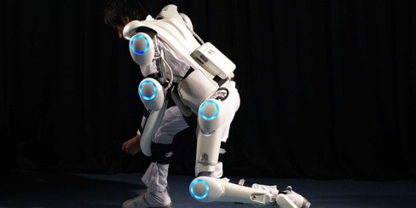
The Study of Feasibility and Effectiveness of Robotic Suit applying in Hong Kong Construction Industry with Suggested Modifications for a Prototype
Student : Norman Wong Tsz Shing
Supervisor : Dr. Ivan Fung
Introduction
Manual transport has long been a problem for construction industry. The injuries caused by manual transport rank third in the construction industry [Labour Department, 2015]. When the workers have to lift heavy objects, their back, arms, and shoulders will be stressed. Repetitive and long lifting time will cause injuries at the mentioned locations. Especially for the aging workforce, their physical quality becomes lower and will easily get injured. According to figures, the average sick leave for the injury caused by manual lifting is 135 days and the longest sick leave will be 915 days. [OSH, 2014] The cost of the problem is significant which greatly reduces the productivity. This document proposed a research direction of using the robotic suit to tackle the mentioned problem. The proposal will include my methods for gathering information, a schedule for the research, and my qualification.
Statement of Problem
As mentioned in the introduction, manual lifting in the construction industry is an important issue. To deal with this issue, using the robotic suit will be a solution. But using the robotic suit is rare in Hong Kong construction industry. We can hardly see the workers wearing the suit in the site. In a meeting with a Gammon Inno. Manager (17th Oct, 2016), Andy Wong, he says that their company has only purchased two robotic suit and is now analyzing the effectiveness of the suit. He added that the reason why the robotic suit is not commonly used because there is no research for the cost effective analysis and most of the designs of the suit do not perfectly fit to the industry.
As this technology is relatively new, it lacks the research support on the cost effective analysis and the risk reduction analysis in the construction industry. That is the main reason why it is not popular used.
Besides, most of the designs of the suit are for the medical use and logistic use. The environment in construction site is far more complicated and thus the suits in the market are not perfectly fit in the local construction environment.
Objectives
I propose to do a research on the cost effectiveness and the risk reduction on the using of robotic suit. By reviewing the robotic suits on the market: SUIT X, HAL®, and Panasonic, choose at least one of the prototype to do the research. There are three objective in the research.
1) To study the cost effectiveness of the robotic suit;
2) Find out the risk reduction after using the robotic suit;
3) Identify the shortcoming on the design of the exoskeleton of the robotic suit; and
4) Suggest the modifications in order to fit in Hong Kong construction site environment.
For the cost effective analysis, the parameters to be included will be the cost of the equipment, the output rate of wearing the suit, the workforce needed in the traditional manual transport, compensation due to the injuries caused by manual transport. By considering all these factors, try to provide a report on the cost effectiveness on the technology.
For the risk reduction analysis, the aim is to quantify the chance of getting injury after the application of the technology. The parameter to be included will be the stress figures in different locations on the body before and after using the suit. The operating hour of getting fatigue by using the suit. By considering these figures, find out the level of risk reduction.
For the modification suggestion, by demonstrating the robotic suit available on the market, find out the shortcoming on the existing design. Besides, having a site visit to understand the site condition in manual transport. By considering these two outcomes, propose some suggestion for the modification.
Plan of Actions
This section presents my plan for obtaining the data I needed to attain my objectives discussed in the previous section. As most of the data required cannot directly find in the literature, the main ways for my data collection will be demonstration, interview, and site visit.
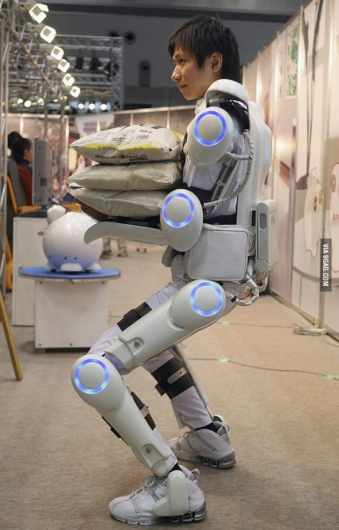
I am drafting a visiting letter to the CYBERDYNE Inc. (Japan) for support, and hope that they can provide some of the information of their prototype, for example the output rate, the shortcomings, and so on. Moreover, I will go to their company in Japan in December to have a demonstration by myself to test the product. And may have an interview with the staff in the company for more information on their products. By trying the prototype directly, I can have a better understanding on the design and can use the experience for further study on the modification.
I will also try to contact the Harvard Biodesign Lab group, which is studying the Soft Exosuits. They have an innovative study on the Exosuits design. Hope I can keep contact with the group by email and can ask for the advice on the information on the robotic suits.
I will also find support from the Gammon Ltd. In the meeting on the 17th Oct, 2016, the Inno. Manager has promised me that I can have a try on the two robotic suits that they have purchased and can have a site visit on their site if I request. By having a site visit, I will collect the site data, and also may have a survey with the workers on the site.
For the information about the muscle fatigue, I will find Dr. Chan Hoi Chung Samuel for advice. He is an expert in RSI and he is the advisor doctor in the Institute of Safety & Health Practitioners. By having an interview with him, I may find the data of how to carry a test to find the fatigue index before and after using the technology.
Management Plan
This section is my schedule, costs and qualification for completing the research.
For the schedule of my work, the overall schedule is shown in the following diagram.
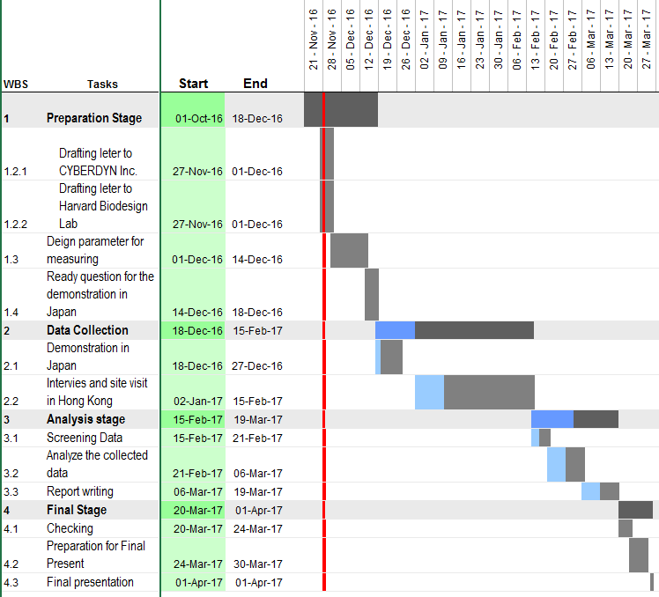
For the early December, it will be the Preparation Stage. All the setting of the questionnaires design, letter drafting for asking support and research parameters should be finished in this stage.
For the Data Collection Stage, I will attend the demonstration in Japan will start in the middle of December. After coming back to Hong Kong, I will contact with the supporter for a site visit and start to collect data from the workers. The data collection is proposed to last for a month or a half and a month.
For the Analysis Stage, I will have to analyze the data collected and complete the final report.
The proposed project days will be last for 131 days.
The cost of the project will be the visiting cost in Japan (around JPD 15000 for the demonstration studio). Besides, some small gifts may be provided to the interviewers. I estimate the total cost in the data collection will not exceed $2000.
I am the year 4 undergraduate student in the Architecture and Civil Engineering Department, majoring in Construction Engineering and Management. I have joined the young member committee in the Institute of Safety & Health Practitioners. I believe my study and my pose will aid me in preparing my research.
Conclusion
By doing this report, I hope that I can help introduce the robotic suit to the Hong Kong construction industry. This technology can enhance the safety and health of the construction workers. Hope the research can help the construction company to make a decision in using this technology and upgrade the health condition of the workers.

Reference
- 香港受傷僱員的職業安全健康狀況調查 (2014). Retrieved October 8, 2016 from Occupational Safety & Health Council, Web site: http://www.oshc.org.hk/others/bookshelf/oshc_research_201411.pdf
- 職業安全及健康統計數字 (Aug 2015). Retrieved October 12, 2016 from Labour Department, Web site: http://www.labour.gov.hk/tc/osh/pdf/OSH_Statistics_2014_TC.pdf
- Soft Exosuits, Retrieved November 24, 2016 from Harvard, School of Engineering and Applied Sciences Web site: http://biodesign.seas.harvard.edu/soft-exosuits
- Shoemaker, N., Don't Replace Humans with Robots — Allow Humans to Do What Robots Can. Retrieved November 6, 2016 from Harvard, School of Engineering and Applied Sciences Web site: http://bigthink.com/natalie-shoemaker/suitx-wants-to-enhance-human-laborers-with-max-exoskeleton
- The World's First Cyborg-type robot "HAL", Retrieved October 3, 2016 from Harvard, School of Engineering and Applied Sciences Web site: http://www.cyberdyne.jp/english/products/HAL/

