**The HKIE Joint Student Chapters Competition**

**2016-2017**

**I²- Initiate Innovation**

**Proposal for a UAV Monitoring System for Tracking Construction and Demolition (C&D) Wastes along Rivers at Developing Country**

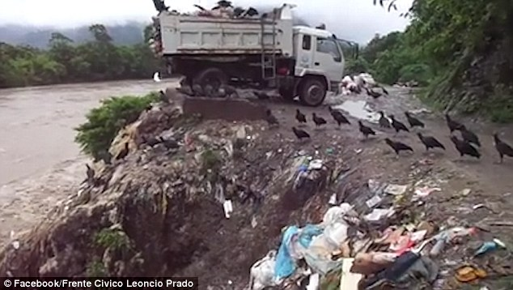

**Team Name: LWCKY**

**Team Supervisor: Dr. Ivan Fung**

**Team Members: CHEN Weiyi**

**KE Linyuwen**

**LU Guangrui**

**WEI Linhao**

**YANG Ye**

**Submission Date: 06/01/2017**

**Introduction**

**Background**

Aiming to connect China with other countries in Asia, Africa and Europe, the “One Belt One Road” initiative was first put forward by Xi Jinping, Chinese President, in 2013. OBOR includes 65 countries in the regions mentioned above, hammering at forming linkage via different aspects including trade, policy, infrastructure, etc. This proposal mainly focuses on a design used to help Bangladesh, one of the Asian countries involved in OBOR, with its water pollution caused by construction and demolition (C&D) wastes.

**Problem Statement**

Bangladesh lies in the northeast of South Asia, with one of the highest population density in the world. Its capital city, Dhaka, relies greatly on a river called Buriganga River, which flows past through west and south of the city. The river provides water for loads of uses, such as irrigation, commercial transportation and so on. However, the river itself now is suffering from serious pollution problem, which brings down the living quality and influences people’s health in Dhaka to a large degree.

There are various sources of the contamination of Buriganga River. A study conducted by Fung, I. W. H. et al. classified the sources of pollution into three categories mainly: industrial pollutants, domestic pollutants and clinic pollutants. Different kinds of industries are polluting the river, among which metalwork and construction are involved. Closely related to the construction industry (construction/demolition), the metalwork factories may just dump the waste into the river and bring about severe contamination. As for the construction industry, possibility of polluting the river lies in a large amount of activities. The contaminants include some harmful chemicals (diesel, paint, etc.), construction debris and dirt, building materials (such as cement), and the soil running into the river caused by the cleaning of the ground.

Nevertheless, the situation of the production of steel in Bangladesh still requires growth in construction industry. According to Dr. Mohammed Mohsin, Chairman of Rahim Group (one of the leaders in the steel industry in Bangladesh), currently, the production capacity of steel is larger than the demand in Bangladesh. The expansion of the companies in steel industry requires a rise in demand of approximately ten percent, which “is not happening”. Therefore, the support of construction growth from the government seems to be vital for the steel industry, which is regarded as the mainstay industry for a country’s development. In other words, for Bangladesh, the construction industry has a tendency of increasing.

Obviously, the construction industry is critical for the national economy. Yet, with its sustaining development, the situation of the contamination of Buriganga River will become even worse.

**Needs Statement**

In consideration of the present situation of the Buriganga River and the life quality of the people living nearby, a high-tech system is badly in need to monitor and manage the construction waste that lead to a worse scenario.

In this proposal, an unmanned aerial vehicle (UAV) monitoring system is designated to collect the information about the C&D waste pollutants along Buriganga River (42km) and send useful data to related departments for further management.

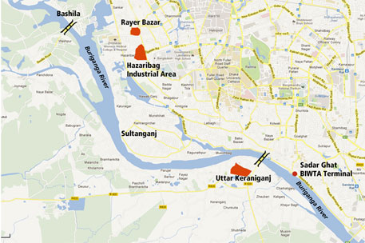

Nonetheless, the economy condition in Bangladesh is not good enough to afford such high-cost system. Based on the statistical data provided by Asian Development Bank, in Bangladesh, 31.5% of the population lives below the national poverty line. Consequently, providing Bangladesh with capital is essential to put the system into application.

**Objectives**

1. To supervise the pollutants related to construction and demolition waste in Buriganga River with higher efficiency by using the UAV monitoring system.
2. To assist in construction waste management in Bangladesh especially in terms of water pollution.
3. To generate the detailed waste map with GPS/GIS mapping for tracking the sources
4. To be in conformity with the “One Belt One Road” initiative proposed by Present Xi Jinping, by offering both funds and technology.

**Design of the UAV River Monitoring System**

As stated in the introduction part, the pollution situation of Buriganga River is severe and there is a rising trend of the Dhaka construction market. Also, construction waste accounts for a non-negligible part in the water pollution. Thus, a river monitoring system is necessary to determine sources of construction pollution and aid the controlling of construction waste dumping. Here a UAV system is designed to reach the purpose.

UAV (unmanned aerial vehicle) river monitoring system is a combination of UAV aerial photography, image identification and water sampling. It is designed to support the hydrological management in both detection of water quality and monitoring the pollution and waste on river to determine the emission point. The UAVs involved in the programme are divided into two groups. One acts as a touring monitor to record videos of river. The other equipped with sample cup, collects pollution specimens by pre-setting. By applying this system to the waste management policy, waste disposal is supposed to be inhibited. At the same time, the timely sampling of waste water can provide research materials on sewage composition and work out the treatment method.

**Basic Information of the UAV**

Speed: 40km/h; flight time: 40 minutes; flying height < 85m; Payload limit: 2kg.

**Data Collection and Processing**

The function of river monitoring mainly contains 5 steps: route setting, UAV cruising, aerial photographing, data transmission and information analysis. The details of each steps are as following:

*Route setting*

Before UAVs are engaged in work, route planning is required to ensure that the shipping line includes the whole watershed with shorter distance. In this case, the contour lines of Buriganga River banks should be extracted and simplified into 2 continuous curves. On the processed graph, every 20 meters a mark is set. Then, connect the corresponding marks of two sides to obtain the quarter points. The two lines, which are formed by the link of the quarter points of two sides respectively, can be regarded as the routes, one for upstream while the other for downstream. The integration of two routes in opposite directions as well as take-off platform and battery platform is an entire UAV sailing circle.

*UAV cruising & aerial photographing*

After route is set up to the embedded computer, start up UAV on the take-off platform. Considering the average width of Buriganga River to be 400m (Imtiaj et al. 2009), and the angle of view of the cameras to be about 50°, the flight height able to cover the whole river can be determined by the following equation

W = 2hTanα,

where W is the width of the camera can capture, h is the height of the camera and α is the angle of view. 2W≥ width of river = 400m. After calculation, h = 85m. At a height above water about 85m, UAVs record videos of Buriganga River with wide- angle camera continuously.

*Data Transmission*

Data chain between UAVs and ground control center is built in this monitoring system, bearing the responsibility of data transfer, remote control and trajectory tracking. In normal operation, wireless transmission with high resolution is applied. Through this transmission channel, statistics from video camera, remote sensing devices and working condition specification are transmitted to ground station.

First-perspective video will be shown in the screens inside ground control station for visual inspection. The played videos will be stored in designated databases and kept intact for two weeks in case of short-term calls, after which a zipping process will be conducted to ease tremendous demand for storage space.

*Data Analysis and Tracking Sources*

Aerial video will record all the movements about Buriganga River including emission points, floating rubbish, waste stacked by river banks. They provide evidences for government to trace illegal industry and construction/demolition sites (the sources of waste). GPS/ GIS mapping can be generated (with detailed waste map) for the report and claims, etc. to the government. Corresponding companies will be prosecuted.

*Subsequence researches*

The waste water sampling section is similar to monitoring unit, as they share the same route and supplemented platforms. After analyzing the graphic information provided by monitoring system, researchers are able to target the seriously polluted area or unusual hydrologic phenomenon. To acquire research materials, the UAV with sample cups will be started up to take samples that worth studying.

In this case, UAVs will collect specimens at the points where are marked by researchers in advance. When the UAV detects itself has reached the target location, according to the combination of GPS and working time, it will land gradually instead of flying towards. At the same time, a sample tube (15ml) will be stretched out. The UAV keeps dropping until the water sensor detects that the vehicle body has reached water and then holds for 3 seconds, waiting until sample tube is filled under water. A UAV is equipped with 6 sample tubes, the real-time information will be transferred to base including time, location and tube number once a sampling is completed.

**System Management**

During operation, various problems will occur without proper management. The most common issues come from lightning condition, weather influences and the battery endurance.

*Sensing images*

Under different environment condition, corresponding feasible sensing systems are applied. First step is to parse information after sensing and collection, paving the way for later stage of processing. Suitable software and processing logic should be adopted. For instance, in spectral sensing, it is proved feasible to use ERDAS to extract multiple spectral information for model establishment. Currently, available choices in this area include MultiSpec、IDRISI、ENVI、 ERDAS IMAGINE、ER Mapper、PCI、ARCGIS and SUPERMAP.

*Working condition specification*

This part involves mainly the environment condition and working state of UAVs. Temperature, humidity, visibility, wind speed, flight path and precise position are measured through automatic sensing system and then all the information will be sent to ground station, where software developed with Visual Basic will then record and process these data as programmed (Wang Pei et al. 2014).

For construction waste management in and along rivers, data collected from above aspects can be entered into GIS (Geographical Information System) after alignment to digitally sketch GIS maps. By observing the GIS maps, comprehensive view about the river and construction waste distribution and discharge situation can be obtained for administrative staff to make further arrangements to ease pollution (Al-Saggaf, A., & Jrade, A. 2015).

*Long-time Hovering Ability of UAV*

With the purpose to monitor the river regularly, lasting and daily workability of the UAV is required. Thus, an automated battery swap and recharge system is adopted.

The design theory of this system comes from the paper written by Tuna Toksoz et al. in 2011. Key parts of the system are the hardware platform, the sloped landing plate and microcontrollers (see the graph below). The hardware platform consists of a buffer of 8 batteries in a dual-drum structure. Each drum contains four battery bays connected to four smart-chargers respectively, which function as battery charging and maintenance. And once the UAV is clamped to the pad on the landing plate, the system as a whole provides shore power that assists the instant battery swap without the shutdown of the UAV, which is also called as a hot swap. Then the automatic changing process will be completed by the on-board microcontrollers and one off-board computer.

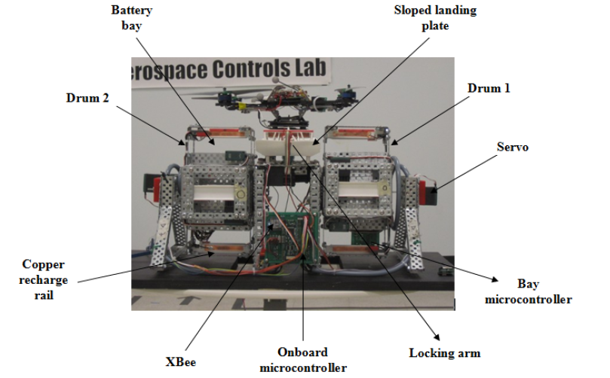

Under current situation that the whole voyage along the Buriganga river is round 18 km as well as the capability of designed Quadrotor UAV to be 40km/h with 40-min endurance, two battery swap systems will be set at the source and mouth of the river. At each end of the river, one telegraph pole will be utilized as power supply and station fixing for the system. One lidded-box containing the system will be fixed near the top of the telegraph pole. And the lid of the box is designed to be waterproof and able to open automatically once the UAV approaches.

With the hot swap mechanism and large charging capability of the system, long-duration flight of the UAV is assured.

**Feasibility study**

**Current applications**

UAV monitoring system, a promising method for environmental monitoring, has been successfully deployed in some countries. In China, UAVs work with cleaning boat to monitor and clean water surface (Ye, 2016). They provide real-time view of river contamination caused by solid waste, industrial discharge and excessive aquatic plants. In Australia, UAVs work with helicopters to monitor and sample water following the release of floods from upstream, to ensure the downstream water quality for irrigation, stockbreeding and domestic use (DPI, 2016). Also in the UK, surveyors adopt UAV system to capture aerial images on site, which engineers then use to follow construction progress and manage construction waste (Prior, 2014).

Based on the design and current applications, it can be concluded that UAV system is convenient and effective in improving water quality and reduce waste discharge. Therefore, to deploy UAV monitoring system in Buriganga River is feasible, but is still restricted by some factors.

**Limitations**

* **Safety**

As is mentioned before, a computer control system is indispensable to operate and follow up UAVs. However, once the system breaks down, or sends a wrong order, aircrafts will soon lose control, which leads to crash, loss or even damages in civilian lives and properties. Therefore, the computer system must be maintained carefully. Moreover, in some remote area, if passers-by have never seen UAVs before, they may interfere with the regular work of aircrafts.

* ***Weather***

Quality of imagery is affected by local weather conditions, as clouds block the sight, rains disturb drones’ flight path and sunlight is reflected by water to the lens. In fact, Bangladesh’s climate is one of the wettest in the world with most rainfalls occurs during June to September (Discoverbangladesh.com). Thus, weatherproof UAV system should be deployed during the monsoon, when the heavy floods worsen contamination of Buriganga River.

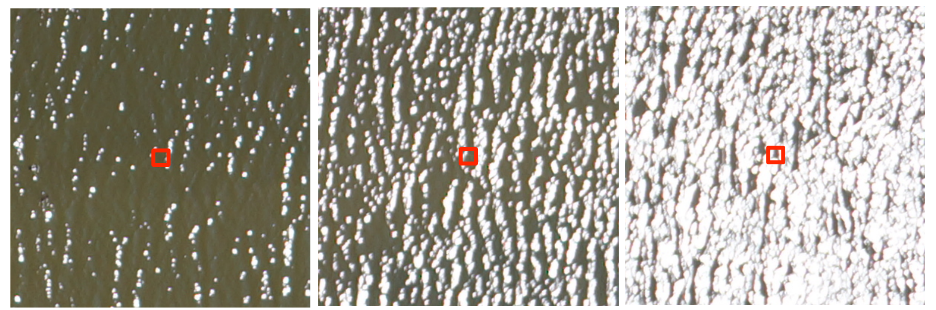

*Fig.3 Sunglint affects the image (Plymouth Marine Laboratory, 2016)*

* **Legislation**

UAV can be regarded as an invasion of privacy in some cases since it carries high-resolution lens and can fly over unreachable places. Bangladesh government allows UAVs with permits to be used commercially. They cannot fly over crowds, airports, military installations, power plants and other regions that may cause local authorities’ concern. Yet, the annual service time is restricted because the law only permits flying during daylight hours in good weather conditions (uavsystemsinternational.com).

**Alternatives**

Existing water quality monitoring methods that are applied in some developed countries may be too expensive and complicated for Bangladesh.

In-situ sampling method requires sufficient advanced laboratory equipment and well-trained personnel, and sufficient number of samples to represent the characteristics of the entire river. Moreover, the result cannot reveal the timely change of water quality precisely, making this method time consuming and labor demanding.

Satellite remote sensing method highly relies on the local atmospheric conditions since excessive clouds block the sight (Ballari, Orellana, Acosta, Espinoza & Morocho, 2016). However, based on Bangladesh’s tropical monsoon climate with frequent and heavy rainfall (Discoverbangladesh.com), weatherproof satellite must be used which rises the total budget and technical requirement.

**Conclusion**

Based on the high profile of One Belt One Road initiative, we propose a UAV river monitoring system to assist in construction and demolition waste management of Buriganga River in Bangladesh. Two groups of UAVs take the responsibility of monitoring and sampling respectively, to collect data and specimens for further analysis. UAVs adopted in the design can fly at 40 km/h for at most 40 minutes and equipped with battery swap & recharge system to ensure daily workability.

UAV river monitoring system has been successfully deployed in countries like China and Australia. For Bangladesh, UAV is a suitable method compared to in-situ sampling and satellite remote sensing, though the practical application may be impeded by local climate and regulations. With the technical and financial support provided by China and other countries, the system will certainly make a difference.

**Reference**

1. <http://www.discoverybangladesh.com/meetbangladesh/climate.html>
2. <https://www.exeter.ac.uk/media/universityofexeter/esi/documents/uavmeetingpapers/P._Land_Potential_of_UAVs_for_water_quality_management.pdf>
3. <https://uavsystemsinternational.com/drone-laws-by-country/bangladesh-drone-laws/>
4. Al-Saggaf, A., & Jrade, A. (2015, June 30). Benefits of integrating BIM and GIS in construction management and control [C]. doi: http://dx.doi.org/10.14288/1.0076369
5. Ballari, D., Orellana, D., Acosta, E., Espinoza, A., & Morocho, V. (2016). UAV monitoring for environmental management in Galapagos Islands. *The International Archives of the Photogrammetry, Remote Sensing and Spatial Information Sciences*, Vol. XLI-B1.
6. Department of Primary Industries, NSW, Australia (2016) Drones deployed to manage water quality in Darling River. Retrieved from <http://www.dpi.nsw.gov.au/about-us/media-centre/releases/2016/drones-deployed-to-manage-water-quality-in-darling-river> on Jan, 2017.
7. Imtiaj H., Sultana R., Kazi A. K. and Gulshan A. L. (2009) Comparative Study on the Water Quality Parameters in Two Rural and Urban Rivers Emphasizing on the Pollution Level. *Global Journal of Environmental Research* Vol.3 (3), 2009, p218-222
8. Prior, G. (2014) Flying drones to check on construction site waste. *Construction Enquirer.* Retrieved from <http://www.constructionenquirer.com/2014/06/25/flying-drones-to-check-on-construction-site-waste/> on Jan, 2017.
9. Tuna Toksoz et al. (2011) Automated Battery Swap and Recharge to Enable Persistent UAV Missions. In Infotech@Aerospace 2011. American Institute of Aeronautics and Astronautics, 2011.
10. Wang Pei, Luo Xiwen, Zhou Zhiyan, et al. Key technology for remote sensing information acquisition based on micro UAV[J]. Transactions of the Chinese Society of Agricultural Engineering (Transactions of the CSAE), 2014, 30(18): 1－12. (In Chinese with English abstract)
11. Ye, H. Q. (2016) Special river chief to monitor river quality in real-time. *Zhejiang Daily.* Retrieved from <http://zjrb.zjol.com.cn/html/2016-12/13/content_3025338.htm?div=0> on Jan, 2017.