**ACE BEng. (CEM) Student, Mr. Heison Chan engaged in CityU Employer’s Luncheon 2017**

This event was held in 16 March 2017 by the Student Development Services, City University of Hong Kong, the exhibition located in Convention Foyer, Hong Kong Conventional and Exhibition Centre (Old Wing). Dr. Ivan Fung (The supervisor) nominated one of his FYP students, Mr. Heison Chan to join this exhibition to present one innovative UAV system to potential employers from different fields or industries.

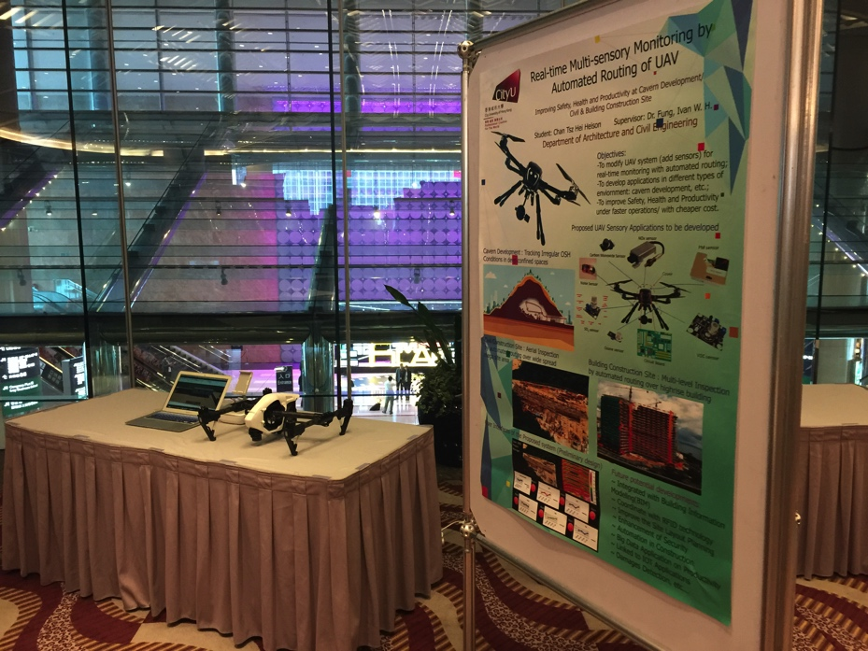

Photo A: Setup in Employer’s Luncheon Exhibition

Photo A showed the basic setup of the exhibits during Employer’s Luncheon, which consisted of one A0 poster showing all the details of the idea in the final year project, and there is an example on the professional model of Drone, ***DJI’s Inspire 1 \****, and the labtop computer is mainly for demonstrating the UAV system applied in Civil construction site as well as Building Construction Site.  ***\* The Model has been supported by Mr. Peter Lai, Safety Specialist Services Limited***

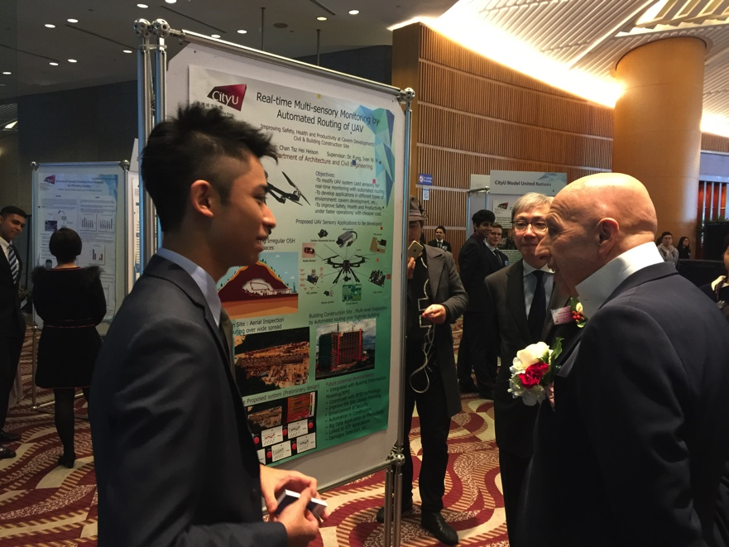

Photo B: Presentation to the VIP: Dr. Allan Zeman

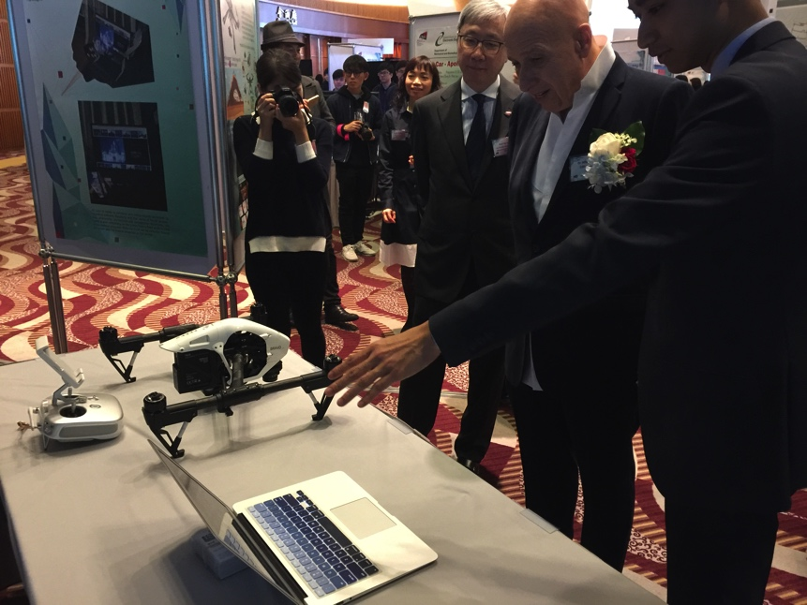

Photo C: Virtual Construction Site Demonstration (Automated UAV System) to Dr. Allan Zeman

The first honorable guest to the exhibition is Dr. Allan Zeman, which is our VIP alumni of City University of Hong Kong, Mr. Heison Chan have presented the whole idea to him, also showing the demonstration of using UAV system in Civil Construction Site and Building Construction Site. And he commented that the whole concept and idea was very clear and good that is innovative to construction industry and he was looking forward to seeing the completion of this project and encouraged the student to keep it up and think of more innovative idea to contribute to construction industry.

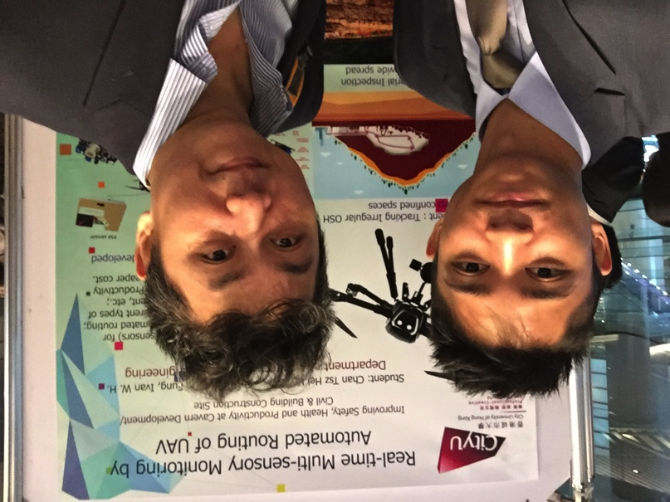

Photo D: Short interview with Mr. Paul Chan

After presenting with Mr. Paul Chan, Chief Designer of shopping+ , he was impressed by the student’s idea, saying that more drone application will be developed soon, to be used in different industry, e.g construction industry. And he also stated that his company already working on some of the student’s suggested future potential development, like drone integrated with Building Information Modeling (BIM), combination with RFID technology etc. And the drone can become an important role in different field. He then invited the student to exchange ideas after the Luncheon Exhibition, and maybe in the next few months, as he was seeking for potential target that with innovative mind to work in his company.